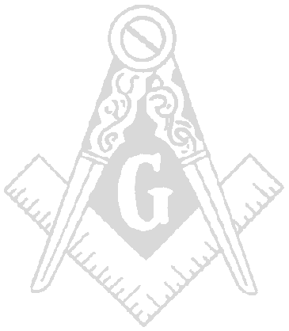
FELLOWSHIP MILITARY LODGE #82
Incirlik Air Base, Turkey

Washington Jurisdiction

PSC 94. Box 672
APO, AE 09824

8 Dec 98

Greetings, all worthy Brethren.

- 19:15 hrs. Opening Ceremonies; Worshipful Master Edwin Jones opened Fellowship Military Lodge #82, located on Incirlik AB, Turkey in Bldg. 480 on the third degree of Masonry.

- Members Present:

a. OFICERS NAMES PRESENT/ABSENT SUBSITUTE
ADDGM/PM Clayton Smith Excused
Past Master Daryl Johnson Present
Worshipful Master Edwin Jones Present
Senior Warden Gregory Bailey Present
Junior Warden Calvin Howell Present
Secretary Amos Ranson Present
Treasurer Lamont Hall Excused
Lecturer Vacant
Marshall Everett Nicholson Present
Chaplain Vacant
Tyler Jean Brooks Present
S. Deacon Reggie Moore Present
J. Deacon Eric Johnson Present
S. Stewart Vacant
J. Stewart Vacant

- Grand Officers Present: None

- Visitors Present: 0

- Total Present: 9

- Reading of the Minutes and Bills: Actions taken.

- Minutes from last communication, 27 Nov 98, for the benefit of the craft.

- Readings of Correspondence: Actions taken.

- None.

- Reports from Standing Committees:

- Sick and distressed: Brother Reels and his wife recently had triplets. And it is a financial burden for them to provide for themselves, the triplets, and a two-year-old.

1. Lodge voted to have Brother Reggie Moore speak to Brother Reels and find out what he needs.
Then report back to the Worshipful Master.

- Petitions: Petition from Andre Thomas read and voted on. It will stand on the altar for 30 days.

- Old Business:

- JW will be appointing a committee to start the process for the Barbecue Fundraiser on 12 December 1998, in the Incirlik AB Club Complex parking lot.

- The grills at the 628th and Arkadas Park need to be attended to prior to the fundraiser.

- JW and Secretary will be attending fundraiser meeting on 30 November 1998, and will report to the WM.

b. JW will appoint a committee to start working on the New Year’s Eve Black and White Ball.

c. WM and JW are setting up a going away party for PM Daryl Johnson on 07 December 1998. The place and time is to be determined.

d. The lodge voted to reimburse JW for the sum of $67.66 for food and refreshments for the
installation on 21 November 1998.

- New Business:

- Worshipful Master has appointed an investing committee to interview petitioners

- Investigation Committee Members:
Reggie Moore
Calvin Howell
Amos Ransom

- The lodge will be sending SW Gregory Bailey to Germany to represent Fellowship Military Lodge #82 at district #9 installation on 12 December 98.

- JW attended a meeting at Incirlik Club Complex on 7 December 98 in reference to acquiring permission and a lot space to have barbecue fundraiser on 12 December 98. Permission was granted and time is yet to be determined.

- The lodge voted to reimburse WM Edwin Jones $100.00 for the purchase of PM Daryl Johnson’s going away gift.

- The following items were discussed and voted on during this communication:

- The theme for 1998-99 will be The Year of the Children.

- Incirlik School is soliciting assistance during its Annual Career Day. PM Smith will be filling
us in on the details.

- Brother Lamont Hall will be starting an Internet web page for Fellowship Military Lodge #82.

- Lodge meeting for 25 Dec 98 is canceled.

- The lodge will be supporting Airman Leadership School with $35.00 per quarter to pay for refreshments for the classes.

- The lodge will be supporting the Incirlik Annual Awards Banquet with a savings bond to the winner of each category.

- A luncheon will be held once a month for lodge members and their guest.

8. Next meeting will be on 12 January 99 at 1800 hrs.

- Fellowship Military Lodge #82 was closed on the third degree of Masonry at 20:37 hrs.

**ATTESTED BY THE SECRETARY AND SIGNED BY THE PRESIDING OFFICER**

AMOS RANSOM EDWIN R. JONES
Secretary Worshipful Master

