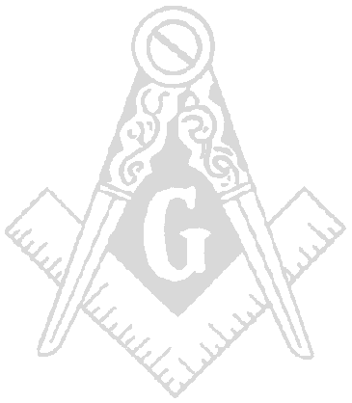
FELLOWSHIP MILITARY LODGE #82
Incirlik Air Base, Turkey

Washington Jurisdiction
PSC 94. Box 672

APO, AE 09824

10 Nov 98

Greetings, All worthy brethren.

- 19:15 hrs. Opening Ceremonies; Worshipful Master Daryl Johnson opened Fellowship Military Lodge #82, located on Incirlik AB, Turkey in Bldg. 480 on the third degree of Masonry.

- Members Present:

a. OFICERS NAMES PRESENT/ABSEN SUBSITUTE
ADDGM/PM Clayton Smith Present
Worshipful Master Daryl Johnson Present
Senior Warden Timothy Johnson Excused Edwin Jones
Junior Warden John Washington Excused Greg Bailey
Secretary Darren Milliken Excused Calvin Howell
Treasurer Kenneth Gause Excused Lamont Hall
Lecturer Michael Breedlove Excused
Marshall Scott Absent Jean Brooks
Chaplain Greg Bailey Present Sub JW
Tyler Everett Nicholson Present
S. Deacon Reggie Moore Present
J. Deacon Ricky Nelson Excused Eric Johnson
S. Stewart Thomas Valerio Excused
J. Stewart Excused

- Grand Officers Present: None

- Visitors Present: 1

- Total Present: 11

- Reading of the Minutes and Bills: Actions taken.
- None

- Readings of Correspondence: Actions taken.

- DDGM Andrew Morgan summoned all newly elected lodge officers to attend the district #9 installation in Germany.

- Reports from Standing Committees:
a. Sick and distressed: None

- Petitions: Petition from Perry D. Rorie read and voted on. It will stand on the altar for 30 days.

- Old Business:

- Lodge voted to compensate Brother Reggie Moore $452.00 for the repairs to his computer. His hard drive was destroyed after the lodge home for a going away function.

- New Business:

a. A fish fry fundraiser is scheduled for 25 Nov 98 in front of the Incirlik commissary.

- A barbecue fundraiser is scheduled for 12 Dec 98 in the Incirlik Club Complex parking lot.

- ADDGM Clayton Smith conducted elections for 1998-99. The new officers are:

- WORSHIPFUL MASTER: EDWIN JONES

SENIOR WARDEN: GREGORY BAILEY

JUNIOR WARDEN: CALVIN HOWELL
- SECRETARY: AMOS RANSOM
- TREASURER: LAMONT HALL

- ADDGM Clayton Smith has invited all members and their families to attend the installation of
the new lodge officers on 21 Nov 98 at 1600 hrs.

- Next meeting will be on 27 Nov 98 at 1800 hrs.

- Fellowship Military Lodge #82 was closed on the third degree of Masonry at 21:11 hrs.

**ATTESTED BY THE SECRECTARY AND SIGNED BY THE PRESIDING OFFICER**

AMOS RANSOM EDWIN JONES
SECRECTARY WORSHIPFUL MASTER

